**Web Technology**

**Session 2: 05/09/2023**

* **Global Attributes**

1. Class

<style>

.myclass{

background: lightblue;

}

</style>

<p class="myclass">This is a class</p>

Output:



1. Id

<style>

#myID{

background: lightblue;

color: red;

}

</style>

<p id="myID">This is an id</p>

Output:

1. Access Key

<input type="text" accesskey="w">

1. Data –

**<body>**

**<ul>**

**<li id="html" onclick="showType(this)" data-lang-type="structure to a webpage" value="HTML">Html</li>**

**<li id="css" onclick="showType(this)" data-lang-type="styling to a webpage">CSS</li>**

**<li id="js" onclick="showType(this)" data-lang-type="functionality to a webpage">JS</li>**

**</ul>**

**<script>**

**function showType(lang){**

**let dt = lang.getAttribute("data-lang-type");**

**alert(lang.innerHTML + " gives " + dt)**

**}**

**</script>**

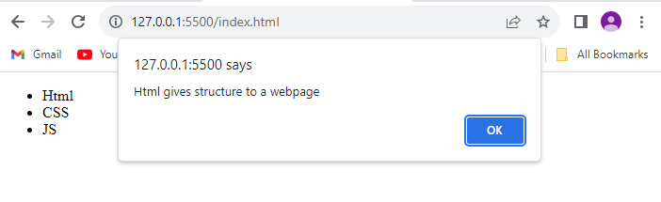

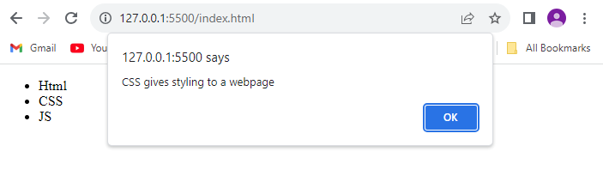

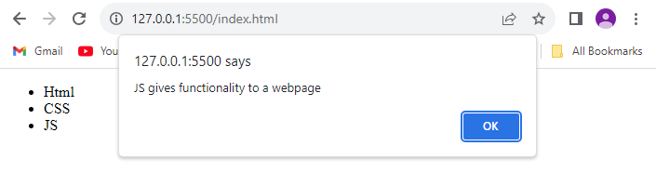

1. Hidden

<input type="text" hidden="true"/>

1. Content Editable

<p contenteditable="true">This is an id</p>

Output:

1. Draggable

<p draggable="true">This text is draggable</p>

Output:

1. Title

<p title="title">This text has title</p>

Output:

1. Tab Index

<input type="text" tabindex="2">

1. Direction

<input type="text" name="" id="" tabindex="2" dir="rtl">

Output:

1. Spellcheck

<input type="text" name="" id="" tabindex="1" spellcheck="true">

Output:

* **Image and HyperLinks**

1. Image Tag

<img src="./favicon.png" alt="Image" width="50" height="50">

Output:

1. Image Map

<img src="https://images.unsplash.com/photo-1682685797365-41f45b562c0a?ixlib=rb-4.0.3&ixid=M3wxMjA3fDF8MHxwaG90by1wYWdlfHx8fGVufDB8fHx8fA%3D%3D&auto=format&fit=crop&w=1740&q=80"

        alt="Image-2" height="400" width="600" usemap="#web">

    <map name="web">

        <area shape="rect" coords="10,50,100,150" href="https://www.google.com/" alt="" target="_blank">

    </map>

1. Anchor Tag

<a href="https://www.google.com/" target="_blank">Google</a>

Output:



1. Base Url

<head>

    <base href="https://kjsim.somaiya.edu/en/">

</head>

<br><a href="alumni-overview/">Alumni</a>

<br><a href="career/">Career</a>

<br><a href="faqs/">FAQs</a>

Output:

**Session 3: 06/09/2023**

* **List Tags**
* Ordered List

<ol>

        <li>web tech</li>

        <ol type="a">

            <li>html</li>

            <li>css</li>

            <li>js</li>

        </ol>

        <li>adv java</li>

        <li>mobile app dev</li>

    </ol>

Output:

* Unordered List

<ul>

   <li>web tech</li>

     <ul type="square">

       <li>html</li>

       <li>css</li>

       <li>js</li>

     </ul>

<li>adv java</li>

   <li>mobile app dev</li>

</ul>

Output:

* Data List

<dl>

  <dt>web tech</dt>

<dd>html</dd>

      <dd>css</dd>

      <dd>js</dd>

   <dt>adv java</dt>

   <dt>mobile app</dt>

</dl>

Output:

* **Table**

<head>

    <style>

        table{

            width: 100%;

            text-align: center;

        }

        caption{

            font-size: large;

            font-weight: 600;

        }

        th{

            background-color: lightblue;

        }

        th,td{

            padding: 1em 0;

        }

    </style>

</head>

<table>

    <caption>KJSIM Courses</caption>

    <thead>

        <tr>

            <th>Courses</th>

            <th>Credits</th>

            <th>Faculty</th>

            <th>Email</th>

        </tr>

    </thead>

    <tbody>

        <tr>

            <td>Web Tech - 1</td>

            <td>4</td>

            <td>Prof. Sudarshan</td>

            <td>sudarshan@somaiya.edu</td>

        </tr>

        <tr>

            <td>DMBS</td>

            <td>4</td>

            <td>Prof. Sangeetha</td>

            <td>sangeetha@somaiya.edu</td>

        </tr>

        <tr>

            <td>AI</td>

            <td>2</td>

            <td>Prof. Archana</td>

            <td>archana@somaiya.edu</td>

        </tr>

        <tr>

            <td>Web Tech - 2</td>

            <td>4</td>

            <td>Prof. Kirti</td>

            <td>kirti@somaiya.edu</td>

        </tr>

    </tbody>

</table>

Output:

* **Form**

<form action="" method="">

    <fieldset>

        <legend >Login Form</legend>

        <label for="uname">Enter Username</label><br>

        <input type="email" name="uname" id="uname"><br><br>

        <label for="pwd">Enter Password</label><br>

        <input type="password" name="pwd" id="pwd"><br><br>

        <button type="submit">Submit</button>

    </fieldset>

</form>

Output:

**CSS**

**Session 6: 20/09/2023**

**CSS Selectors**

1. **Universal Selector**

style>

        *{

            background-color: lightblue;

        }

    </style>

<body>

</body>

1. **Class Selector**

<style>

        *{

            background-color: lightblue;

        }

        .heading{

            text-align: center;

        }

    </style>

<body>

        <h1 class="heading">CSS Selectors</h1>

</body>

1. **ID Selector**

    <style>

        *{

            background-color: lightblue;

        }

        .heading{

            text-align: center;

        }

        #heading-text{

            color: blue;

        }

    </style>

<body>

        <h1 class="heading" id="heading-text">CSS Selectors</h1>

</body>

1. **Group Selector**

   <style>

        *{

            background-color: lightblue;

        }

        .heading, p{

            text-align: center;

        }

        #heading-text{

            color: blue;

        }

    </style>

</head>

<body>

        <h1 class="heading" id="heading-text">CSS Selectors</h1>

        <p>Lorem ipsum dolor sit amet consectetur adipisicing elit. Inventore, omnis.</p>

</body>

1. **Combinator Selector**
   1. **Descendent( )**

    <style>

        *{

            background-color: lightblue;

        }

        .heading, p{

            text-align: center;

        }

        #heading-text{

            color: blue;

        }

        div h2{

            color: red;

        }

    </style>

</head>

<body>

        <h1 class="heading" id="heading-text">CSS Selectors</h1>

        <p>Lorem ipsum dolor sit amet consectetur adipisicing elit. Inventore, omnis.</p>

        <div>

            <h2 class="heading">This is a descendent selector</h2>

        </div>

</body>

* 1. **Child(>)**

    <style>

        *{

            background-color: lightblue;

        }

        .heading, p{

            text-align: center;

        }

        #heading-text{

            color: blue;

        }

        div h2{

            color: red;

        }

        div > h2 {

            background-color: white;

        }

    </style>

</head>

<body>

        <h1 class="heading" id="heading-text">CSS Selectors</h1>

        <p>Lorem ipsum dolor sit amet consectetur adipisicing elit. Inventore, omnis.</p>

        <div>

            <h2 class="heading">This is a descendent selector</h2>

        </div>

        <p>Lorem ipsum dolor sit, amet consectetur adipisicing elit. Quas, quos?</p>

</body>

* 1. **Sibling/Adjacent(+)**

    <style>

        *{

            background-color: lightblue;

        }

        .heading, p{

            text-align: center;

        }

        #heading-text{

            color: blue;

        }

        div h2{

            color: red;

        }

        div > h2 {

            background-color: white;

        }

        div + p {

            color: darkgoldenrod;

        }

    </style>

</head>

<body>

        <h1 class="heading" id="heading-text">CSS Selectors</h1>

        <p>Lorem ipsum dolor sit amet consectetur adipisicing elit. Inventore, omnis.</p>

        <div>

            <h2 class="heading">This is a descendent selector</h2>

        </div>

        <p>Lorem ipsum dolor sit, amet consectetur adipisicing elit. Quas, quos?</p>

</body>

* 1. **General Sibling(~)**

    <style>

        *{

            background-color: lightblue;

        }

        .heading, p{

            text-align: center;

        }

        #heading-text{

            color: blue;

        }

        div h2{

            color: red;

        }

        div > h2 {

            background-color: white;

        }

        div + p {

            color: darkgoldenrod;

        }

        div ~ p{

            background-color: yellow;

        }

    </style>

</head>

<body>

        <h1 class="heading" id="heading-text">CSS Selectors</h1>

        <p>Lorem ipsum dolor sit amet consectetur adipisicing elit. Inventore, omnis.</p>

        <div>

            <h2 class="heading">This is a descendent selector</h2>

        </div>

        <p>Lorem ipsum dolor sit, amet consectetur adipisicing elit. Quas, quos?</p>

        <p>Lorem ipsum dolor sit, amet consectetur adipisicing elit. Quas, quos?</p>

        <p>Lorem ipsum dolor sit, amet consectetur adipisicing elit. Quas, quos?</p>

</body>

* 1. **Pseudo Class Selector**

    <style>

        *{

            background-color: lightblue;

        }

        .heading, p{

            text-align: center;

        }

        #heading-text{

            color: blue;

        }

        div h2{

            color: red;

        }

        div > h2 {

            background-color: white;

        }

        div + p {

            color: darkgoldenrod;

        }

        div ~ p{

            background-color: yellow;

        }

        p:hover{

            color: red;

        }

    </style>

</head>

<body>

        <h1 class="heading" id="heading-text">CSS Selectors</h1>

        <p>Lorem ipsum dolor sit amet consectetur adipisicing elit. Inventore, omnis.</p>

        <div>

            <h2 class="heading">This is a descendent selector</h2>

        </div>

        <p>Lorem ipsum dolor sit, amet consectetur adipisicing elit. Quas, quos?</p>

        <p>Lorem ipsum dolor sit, amet consectetur adipisicing elit. Quas, quos?</p>

        <p>Lorem ipsum dolor sit, amet consectetur adipisicing elit. Quas, quos?</p>

</body>

**Session 7: 25/09/2023**

1. **Child**

<style>

p:first-child{

background-color: red;

}

p:last-child{

background-color: yellow;

}

</style>

<div>

<p>1st para</p>

<p>2nd para</p>

<p>3rd para</p>

</div>

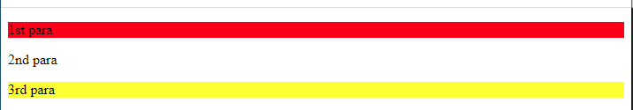

1. **Input**

**<style>**

**input{**

**padding: 10px;**

**border-radius: 10px;**

**border: none;**

**}**

**input:empty{**

**background-color: cadetblue;**

**}**

**input:disabled{**

**background-color: gray;**

**}**

**input:active{**

**background-color: blueviolet;**

**}**

**input:checked{**

**border-radius: 50px;**

**height: 20px;**

**width: 20px;**

**}**

**input[type=number]:in-range{**

**border: 2px solid green;**

**background-color: azure;**

**}**

**input[type=number]:out-of-range{**

**border: 2px solid red;**

**background-color: aliceblue;**

**}**

**</style>**

**<div>**

**<input type="text" name="" id=""><br><br>**

**<input type="text" name="" id=""><br><br>**

**<input type="text" name="" id="" disabled><br>**

**<input type="checkbox" name="" id="">**

**<input type="checkbox" name="" id="">**

**<input type="checkbox" name="" id="">**

**</div>**

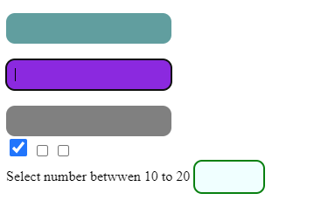

**<style>**

**input:required{**

**background-color: burlywood;**

**}**

**input:read-only{**

**background-color: gainsboro;**

**}**

**</style>**

**<body>**

**<input type="email" required>**

**<input type="email" placeholder="readonly" readonly>**

**</body>**



**<style>**

**p::selection{**

**background-color: red;**

**color: white;**

**}**

**::selection{**

**background-color: black;**

**color: white;**

**}**

**</style>**

**<div>**

**<p>1st para</p>**

**<p>2nd para</p>**

**<p>3rd para</p>**

**</div>**

**<div>**

**<input type="text" name="" id=""><br><br>**

**<input type="text" name="" id=""><br><br>**

**<input type="text" name="" id="" disabled><br>**

**<input type="checkbox" name="" id="">**

**<input type="checkbox" name="" id="">**

**<input type="checkbox" name="" id="">**

**</div>**

**<label for="">Select number between 10 to 20</label>**

**<input type="number" name="range" id="" min="10" max="20">**

**<input type="email" required>**

**<input type="email" placeholder="readonly" readonly>**

**<h4>Lorem ipsum dolor sit, amet consectetur adipisicing elit. Saepe eius sequi molestiae libero minima quisquam placeat autem cum doloremque corporis!</h4>**

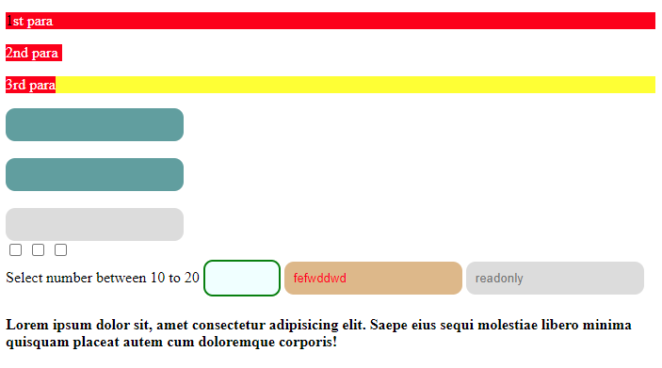

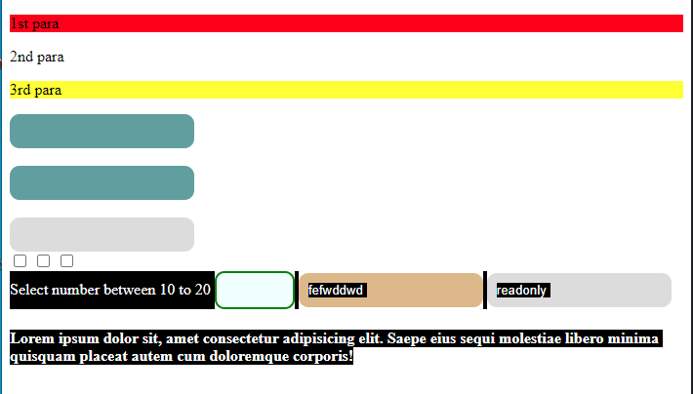

**<style>**

**a::before{**

**content: "Hi! ";**

**color: darkcyan;**

**}**

**a::after{**

**content: " Google";**

**color: darkred;**

**}**

**pre{**

**font-size: 2rem;**

**}**

**pre::first-letter{**

**color: darkred;**

**}**

**pre::first-line{**

**background-color: lightcoral;**

**}**

**</style>**

**<body>**

**<a href="www.google.com">Click to visit</a>**

**<pre>Lorem ipsum dolor sit, amet consectetur adipisicing elit. Reprehenderit quam**

**ipsa impedit voluptatibus aliquid autem ullam eius, eligendi pariatur vero ratione**

**similique quidem perferendis recusandae accusantium fuga corrupti nihil enim.**

**</pre>**

**</body>**

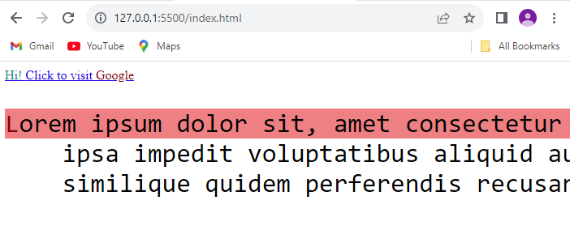

**JavaScript**

* **Alert in JS**

<head>

    <meta charset="UTF-8">

    <meta name="viewport" content="width=device-width, initial-scale=1.0">

    <title>Document</title>

    <script>

        document.write("<h1 style='background-color: lightblue;text-align: center;'>Web technology</h1>")

    </script>

</head>

<body onload="alert('Page Loaded Successfully!');">

</body>

</html>

* **Basic JS Function**

<head>

    <meta charset="UTF-8">

    <meta name="viewport" content="width=device-width, initial-scale=1.0">

    <title>Document</title>

    <script>

        document.write("<h1 style='background-color: lightblue;text-align: center;'>Web technology</h1>")

        function myFunc(){

            // alert("Page Loaded Successfully!")

            return "returning string from function";

        }

    </script>

</head>

<body onload="alert('Page Loaded Successfully!');" onbeforeprint="alert(myFunc());">

</body>

**Session 5: 18/09/2023**

1. **Window Events**

* **Prompt**

    <script>

        function wPrompt(){

            var p = prompt("who are you?");

            alert("you are " + p);

        }

    </script>

<button type="button" value="Prompt" onclick="wPrompt()">Prompt</button>

* **Confirm**

    <script>

        function wConfirm() {

            var c = confirm("do you want to exit?");

            if (c == true)

                alert(c);

            else

                alert(c);

        }

    </script>

<button type="button" value="Confirm" onclick="wConfirm()">Confirm</button>

* **Open**

    <script>

        function wOpen() {

            open("https://www.google.com");

        }

    </script>

<body>

    <button type="button" value="Open Google" onclick="wOpen()">Open Google</button>

</body>

* **Timeout**

<script>

function wTo(){

    setTimeout(() => {

        open("https://kjsim.somaiya.edu/en/");

    }, 5000);

}

</script>

<body>

    <button type="button" value="Go to KJSIM" onclick="wTo()">Go to KJSIM</button>

</body>

**Session 8 - 26/09/2023**

**Registration Form with Javascript**

**<!DOCTYPE html>**

**<html lang="en">**

**<head>**

**<meta charset="UTF-8">**

**<meta name="viewport" content="width=device-width, initial-scale=1.0">**

**<title>Document</title>**

**<style>**

**div{**

**background-color: lightcyan;**

**}**

**input, textarea, select{**

**padding: 10px;**

**border-radius: 5px;**

**border: 1px solid gray**

**}**

**input[type="button"]{**

**background-color: lightskyblue;**

**font-weight: 600;**

**}**

**input[type="reset"]{**

**background-color: rgb(207, 207, 207);**

**font-weight: 600;**

**}**

**pre{**

**font-size: large;**

**font-weight: 500;**

**font-family:'Times New Roman', Times, serif;**

**}**

**h3{**

**padding: 5px;**

**}**

**</style>**

**</head>**

**<body>**

**<div>**

**<form action="">**

**<fieldset>**

**<legend>Registration form</legend>**

**<input type="email" name="" id="email" placeholder="Enter Email"><br><br>**

**<input type="password" name="" id="pwd" placeholder="Enter Password"><br><br>**

**<input type="date" name="" id="dob"><br><br>**

**<input type="radio" name="gender" value="male">Male**

**<input type="radio" name="gender" value="female">Female<br><br>**

**<input type="checkbox" name="degree" id="" value="BA">BA**

**<input type="checkbox" name="degree" id="" value="BCom">Bcom**

**<input type="checkbox" name="degree" id="" value="BSc">BSc<br><br>**

**<textarea name="" id="feedback" cols="20" rows="3"></textarea><br><br>**

**<select name="" id="city">**

**<option value="Mumbai">Mumbai</option>**

**<option value="Pune">Pune</option>**

**<option value="Delhi">Delhi</option>**

**</select><br><br>**

**<input type="button" value="Register" onclick="registration()">**

**<input type="reset" value="Cancel">**

**</fieldset>**

**</form>**

**<hr>**

**<h3>Registration Details</h3>**

**<pre id="output"></pre>**

**</div>**

**<script>**

**function registration(){**

**var email = document.getElementById("email").value;**

**var pwd = document.getElementById("pwd").value;**

**var dob = document.getElementById("dob").value;**

**var gender = document.querySelector("input[name=gender]:checked").value;**

**var degree = document.getElementsByName("degree");**

**var result = " ";**

**for(var i=0; i<degree.length; i++)**

**{**

**if (degree[i].checked)**

**result += degree[i].value + " , ";**

**}**

**var feedback = document.getElementById("feedback").value;**

**var city = document.getElementById("city").value;**

**document.getElementById("output").innerHTML = "<br> Email: " + email + "<br> Password: " + pwd + "<br> DOB: " + dob + "<br> Gender: " + gender + "<br> Degrees: " + result + "<br> Feedback: " + feedback + "<br> City: " + city ;**

**// alert("works");**

**}**

**</script>**

**</body>**

**</html>**

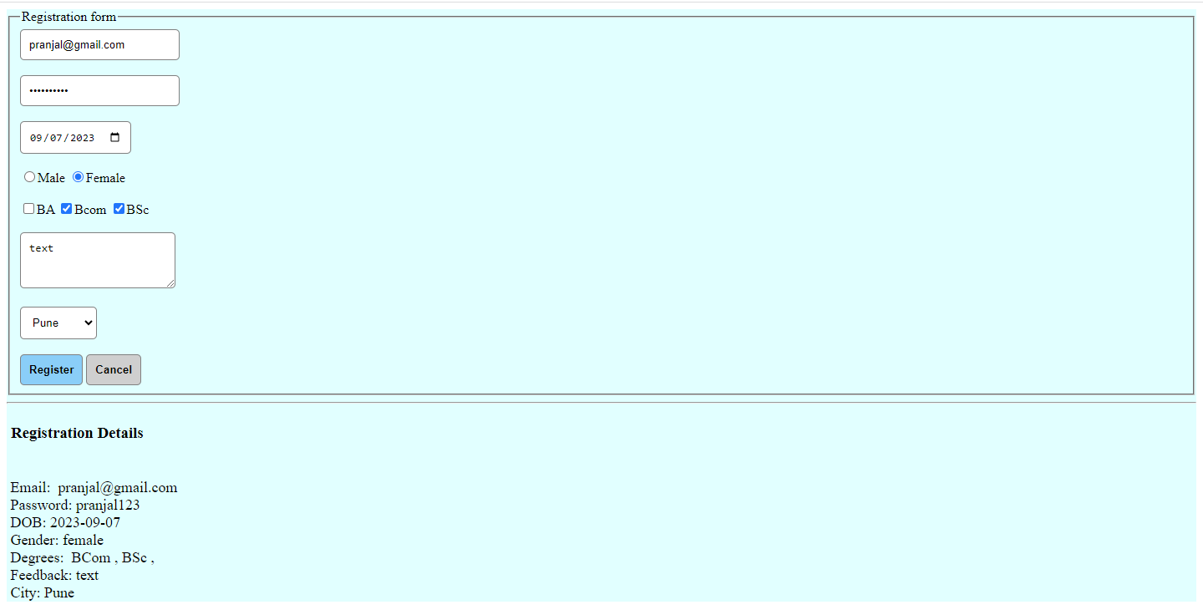

**Inner HTML**

**<!DOCTYPE html>**

**<html lang="en">**

**<head>**

**<meta charset="UTF-8">**

**<meta name="viewport" content="width=device-width, initial-scale=1.0">**

**<title>Document</title>**

**<style>**

**div{**

**background-color: rgba(198, 245, 245, 0.541);**

**padding: 10px;**

**border-radius: 5px;**

**}**

**input{**

**padding: 10px;**

**border-radius: 5px;**

**border: 1px solid gray**

**}**

**input[type="button"]{**

**background-color: lightskyblue;**

**font-weight: 600;**

**margin-right: 10px;**

**}**

**input[type="button"]:hover{**

**background-color: rgb(164, 213, 255);**

**}**

**input[type="reset"]{**

**background-color: rgb(207, 207, 207);**

**font-weight: 600;**

**}**

**button{**

**padding: 10px;**

**border-radius: 5px;**

**border: 1px solid gray;**

**background-color: lightskyblue;**

**}**

**</style>**

**</head>**

**<body>**

**<button onclick="showForm()">Show Feedback Form</button>**

**<div id="myarea"></div>**

**<script>**

**function showForm(){**

**var myForm = '<br><input type="email" name="" id="email" placeholder="Enter Email"><br><br>' +**

**'<input type="password" name="" id="pwd" placeholder="Enter Password"><br><br>' + '<input type="date" name="" id="dob"><br><br>' + '<input type="button" value="Register" onclick="registration()">' +**

**'<input type="reset" value="Cancel">'**

**document.getElementById("myarea").innerHTML = myForm;**

**}**

**</script>**

**</body>**

**</html>**

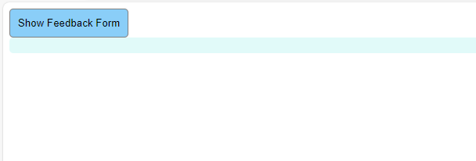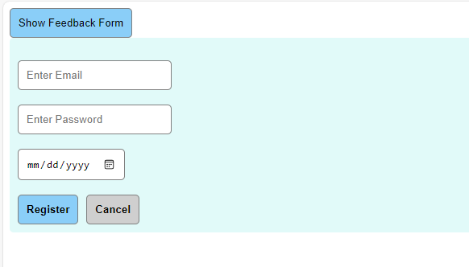

**OOPS**

**<!DOCTYPE html>**

**<html lang="en">**

**<head>**

**<meta charset="UTF-8">**

**<meta name="viewport" content="width=device-width, initial-scale=1.0">**

**<title>Document</title>**

**</head>**

**<body>**

**<script>**

**// js class and objects**

**class Student{**

**// constructor - initializing object**

**constructor(rollno,fname, lname){**

**this.rollno = rollno;**

**this.fname = fname;**

**this.lname = lname;**

**}**

**// method definition - class member function**

**showDetails(){**

**document.write("<hr> Student Details: <br>");**

**document.write("<br> Rollno: " + this.rollno);**

**document.write("<br> Name: " + this.fname + this.lname + "<br><hr>");**

**}**

**}**

**var s1 = new Student(1, "pranjal", " sawant");**

**var s2 = new Student(2, "pratik", " sawant");**

**s1.showDetails();**

**s2.showDetails();**

**</script>**

**</body>**

**</html>**

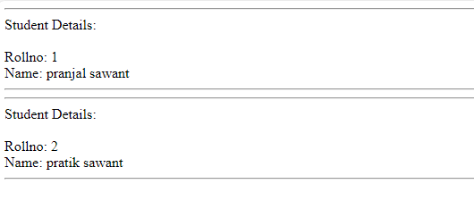

**Creating object using object literal**

**var stud = {rollNo:11, name: 'pranjal sawant', email:'pranjal@gmail.com'}**

**var stud1 = {rollNo:12, name: 'pratik sawant', email:'pratik@gmail.com'}**

**document.write("<br>Roll No : " + stud.rollNo + "<br>Name : " + stud.name + "<br>Email: " + stud.email + "<hr>")**

**document.write("<br>Roll No : " + stud1.rollNo + "<br>Name : " + stud1.name + "<br>Email: " + stud1.email + "<hr>")**

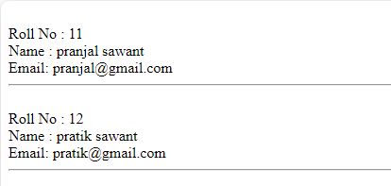

**Creating Object by creating instance of class**

**var faculty1 = new Object;**

**faculty1.name = "Prof. Sudarshan";**

**faculty1.subject = "Web Tech";**

**var faculty2 = new Object();**

**faculty2.name = "Prof. Sangeetha";**

**faculty2.subject = "DBMS";**

**document.write("<br>Faculty Name : " + faculty1.name + "<br>Subject : " + faculty1.subject + "<hr>")**

**document.write("<br>Faculty Name : " + faculty2.name + "<br>Subject : " + faculty2.subject + "<hr>")**

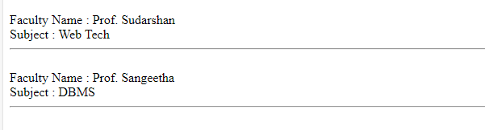

**Creating object using object constructor**

**function Faculty(name, subject){**

**this.name = name;**

**this.subject = subject;**

**// member function is initialized as class property first and then defined as function with function keyword**

**this.showFaculty =showFaculty;**

**function showFaculty(){**

**document.write("<br>Faculty Name : " + this.name + "<br>Subject : " + this.subject + "<hr>")**

**}**

**}**

**var f3 = new Faculty("Prof. ABC" , "AI");**

**f3.showFaculty();**

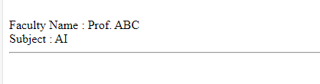

**Bootstrap**

**Session 10 - 03/10/2023**

1. Containers

**<!DOCTYPE html>**

**<html lang="en">**

**<head>**

**<meta charset="UTF-8">**

**<meta name="viewport" content="width=device-width, initial-scale=1.0">**

**<title>Bootstrap</title>**

**<link href="https://cdn.jsdelivr.net/npm/bootstrap@5.3.2/dist/css/bootstrap.min.css" rel="stylesheet" integrity="sha384-T3c6CoIi6uLrA9TneNEoa7RxnatzjcDSCmG1MXxSR1GAsXEV/Dwwykc2MPK8M2HN" crossorigin="anonymous">**

**</head>**

**<body>**

**<!-- containers -->**

**<div class="container border p-2 my-2">Lorem ipsum dolor sit amet consectetur adipisicing elit. Ab, sit!</div>**

**<div class="container-fluid border p-2 my-2">Lorem ipsum, dolor sit amet consectetur adipisicing elit. Odit, nisi?</div>**

**<div class="container-sm border p-2 my-2">Lorem ipsum, dolor sit amet consectetur adipisicing elit. Odit, nisi?</div>**

**<div class="container-md border p-2 my-2">Lorem ipsum, dolor sit amet consectetur adipisicing elit. Odit, nisi?</div>**

**<div class="container-lg border p-2 my-2">Lorem ipsum, dolor sit amet consectetur adipisicing elit. Odit, nisi?</div>**

**<div class="container-xl border p-2 my-2">Lorem ipsum, dolor sit amet consectetur adipisicing elit. Odit, nisi?</div>**

**<div class="container-xxl border p-2 my-2">Lorem ipsum, dolor sit amet consectetur adipisicing elit. Odit, nisi?</div>**

**<script src="https://cdn.jsdelivr.net/npm/bootstrap@5.3.2/dist/js/bootstrap.bundle.min.js" integrity="sha384-C6RzsynM9kWDrMNeT87bh95OGNyZPhcTNXj1NW7RuBCsyN/o0jlpcV8Qyq46cDfL" crossorigin="anonymous"></script>**

**</body>**

**</html>**

Mobile View -

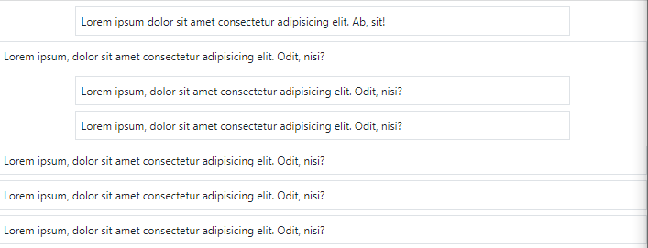

Desktop View -

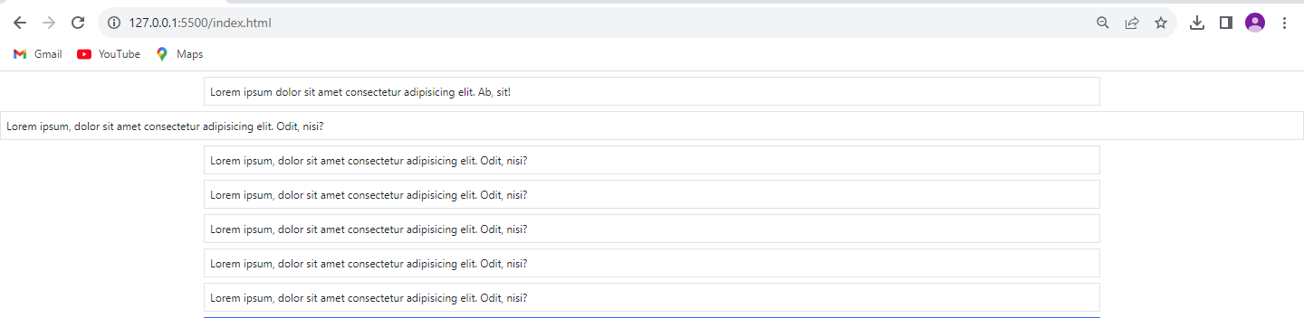

1. Background Colors

**<!-- BG Colors -->**

**<div class="container p-4 bg-primary">.bg-primary</div>**

**<div class="container p-4 bg-dark">.bg-dark</div>**

**<div class="container p-4 bg-success">.bg-success</div>**

**<div class="container p-4 bg-secondary">.bg-secondary</div>**

**<div class="container p-4 bg-info">.bg-info</div>**

**<div class="container p-4 bg-light">.bg-light</div>**

**<div class="container p-4 bg-warning">.bg-warning</div>**

**<div class="container p-4 bg-danger">.bg-danger</div>**

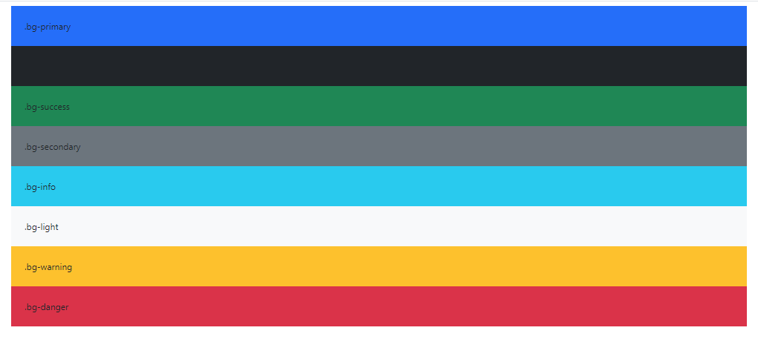

1. Grid System

**<!-- grid system -->**

**<div class="container">**

**<div class="row my-3 border p-2">**

**<div class="col p-2 bg-info">column 1</div>**

**<div class="col p-2 bg-warning">column 2</div>**

**<div class="col p-2 bg-secondary">column 3</div>**

**<div class="col p-2 bg-primary">column 4</div>**

**</div>**

**</div>**



4)Unequal grid system

**<!-- unequal grid system -->**

**<div class="container">**

**<div class="row border my-3 p-3">**

**<div class="col-sm-4 p-3 bg-info">col 1</div>**

**<div class="col-sm-8 p-3 bg-secondary">col 2</div>**

**</div>**

**</div>**



4)Text colors

<!-- text colors -->

<div class="container" style="background-color: rgb(38, 90, 92);">

<p class="text-info">Info Text</p>

<p class="text-primary">Primary Text</p>

<p class="text-secondary">Secondary Text</p>

<p class="text-success">Success Text</p>

<p class="text-danger">Danger Text</p>

<p class="text-dark">Dark Text</p>

<p class="text-light">Light Text</p>

<p class="text-warning">Warning Text</p>

</div>

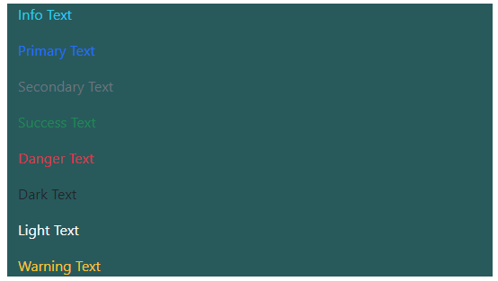

5) Table

<!-- table -->

<div class="container p-5">

<table class="table table-bordered table-hover table-dark table-striped">

<tr class="table-primary">

<th>Name</th>

<th>Email</th>

<th>City</th>

</tr>

<tr>

<td>Pranjal</td>

<td>pranjal@gmail.com</td>

<td>Mumbai</td>

</tr>

<tr>

<td>ABC</td>

<td>abc@gmail.com</td>

<td>Pune</td>

</tr>

<tr>

<td>XYZ</td>

<td>xyz@gmail.com</td>

<td>Delhi</td>

</tr>

</table>

</div>

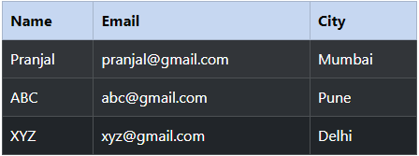

6) Image

<!-- images -->

<div class="container p-2">

<img src="https://images.unsplash.com/photo-1493612276216-ee3925520721?ixlib=rb-4.0.3&ixid=M3wxMjA3fDB8MHxzZWFyY2h8Mnx8cmFuZG9tfGVufDB8fDB8fHww&auto=format&fit=crop&w=200&q=60"

alt="img" class="rounded">

<img src="https://images.unsplash.com/photo-1493612276216-ee3925520721?ixlib=rb-4.0.3&ixid=M3wxMjA3fDB8MHxzZWFyY2h8Mnx8cmFuZG9tfGVufDB8fDB8fHww&auto=format&fit=crop&w=200&q=60"

alt="img" class="rounded-circle">

<img src="https://images.unsplash.com/photo-1493612276216-ee3925520721?ixlib=rb-4.0.3&ixid=M3wxMjA3fDB8MHxzZWFyY2h8Mnx8cmFuZG9tfGVufDB8fDB8fHww&auto=format&fit=crop&w=200&q=60"

alt="img" class="img-thumbnail">

</div>

<div class="container">

<img src="https://images.unsplash.com/photo-1493612276216-ee3925520721?ixlib=rb-4.0.3&ixid=M3wxMjA3fDB8MHxzZWFyY2h8Mnx8cmFuZG9tfGVufDB8fDB8fHww&auto=format&fit=crop&w=200&q=60"

alt="img" class="rounded float-start">

<img src="https://images.unsplash.com/photo-1493612276216-ee3925520721?ixlib=rb-4.0.3&ixid=M3wxMjA3fDB8MHxzZWFyY2h8Mnx8cmFuZG9tfGVufDB8fDB8fHww&auto=format&fit=crop&w=200&q=60"

alt="img" class="rounded float-end">

</div>

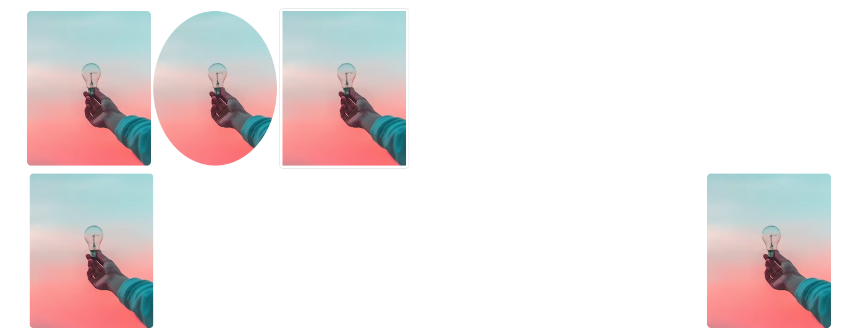

7) Alerts

<!-- alerts -->

<div class="container p-2">

<div class="alert"> Alert</div>

<div class="alert alert-primary">Alert Primary</div>

<div class="alert alert-secondary">Alert Secondary</div>

<div class="alert alert-info">Alert Info</div>

<div class="alert alert-success">Alert Success</div>

<div class="alert alert-warning">Alert Warning</div>

<div class="alert alert-danger">Alert Danger</div>

<div class="alert alert-light">Alert Light</div>

<div class="alert alert-dark">Alert Dark</div>

</div>

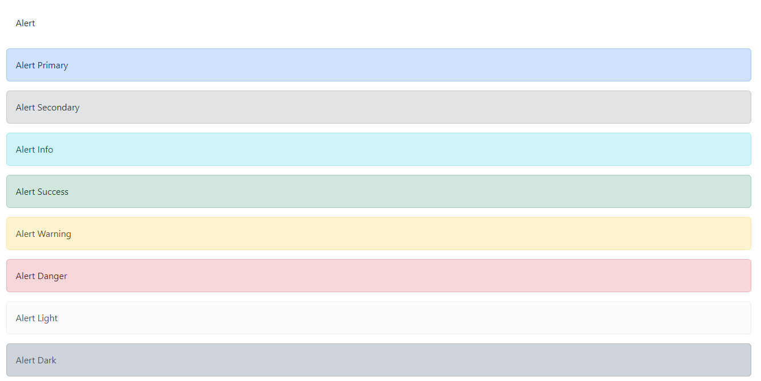

* dismiss alerts

<div class="alert alert-primary alert-dismissible">Alert Primary

<button type="button" class="btn-close" data-bs-dismiss="alert"></button>

</div>

<div class="alert alert-secondary alert-dismissible">Alert Secondary

<button type="button" class="btn-close" data-bs-dismiss="alert"></button>

</div>

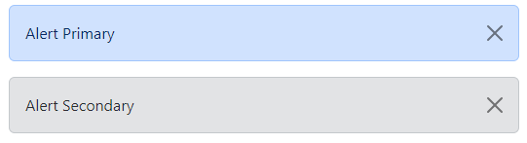

8)Buttons.

<!-- buttons -->

<div class="container">

<button type="button" class="btn m-2 btn-primary">Primary</button>

<button type="button" class="btn m-2 btn-secondary">Secondary</button>

<button type="button" class="btn m-2 btn-success">Success</button>

<button type="button" class="btn m-2 btn-danger">Danger</button>

<button type="button" class="btn m-2 btn-warning">Warning</button>

<button type="button" class="btn m-2 btn-info">Info</button>

<button type="button" class="btn m-2 btn-light">Light</button>

<button type="button" class="btn m-2 btn-dark">Dark</button>

</div>

<div class="container">

<button type="button" class="btn m-2 btn-outline-primary">Primary</button>

<button type="button" class="btn m-2 btn-outline-secondary">Secondary</button>

<button type="button" class="btn m-2 btn-outline-success">Success</button>

<button type="button" class="btn m-2 btn-outline-danger">Danger</button>

<button type="button" class="btn m-2 btn-outline-warning">Warning</button>

<button type="button" class="btn m-2 btn-outline-info">Info</button>

<button type="button" class="btn m-2 btn-outline-light text-dark">Light</button>

<button type="button" class="btn m-2 btn-outline-dark">Dark</button>

</div>

<div class="container">

<button type="button" class="btn m-2 btn-success btn-sm">Small</button>

<button type="button" class="btn m-2 btn-danger btn-lg">Large</button>

<button type="button" class="btn m-2 btn-warning ">Default</button>

</div>

<div class="d-grid">

<button type="button" class="btn m-2 btn-dark">Full Width</button>

</div>

<div class="btn-group">

<button type="button" class="btn btn-primary">Primary</button>

<button type="button" class="btn btn-secondary">Secondary</button>

<button type="button" class="btn btn-success">Success</button>

</div>

<div class="btn-group-vertical">

<button type="button" class="btn btn-primary">Primary</button>

<button type="button" class="btn btn-secondary">Secondary</button>

<button type="button" class="btn btn-success">Success</button>

</div>

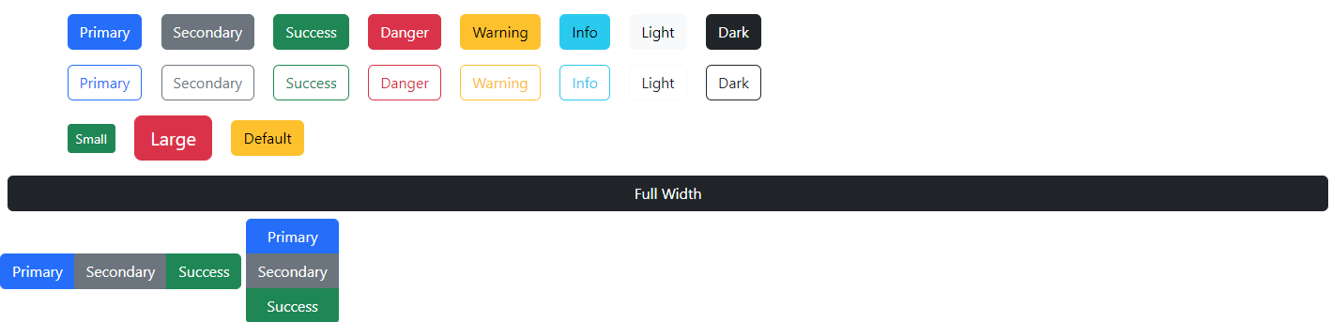

9)List

<!-- list -->

<div class="container p-3">

<ul class="list-group">

<li class="list-group-item">Web Tech</li>

<li class="list-group-item">DBMS</li>

<li class="list-group-item">AI</li>

</ul>

</div>

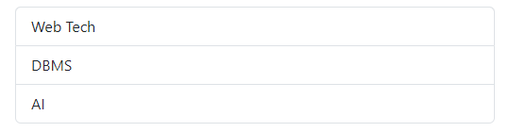

Session 11- 04/10/2023

10)Toast

<h3 class="p-2">Toast</h3>

<div class="container p-5">

<div class="toast show">

<div class="toast-header">

<div class="fw-semibold fs-6">MCAFY 2023-2025</div>

<div class="ms-auto">

<button type="button" class="btn-close" data-bs-dismiss="toast"></button>

</div>

</div>

<div class="toast-body">

<pre>Welcome to the Web Tech Session

HTML

css

JS

</pre>

</div>

<div class="toast-footer">

<div class="d-flex justify-content-end">

<button type="button" class="btn btn-danger m-2 " data-bs-dismiss="toast">Close</button>

</div>

</div>

</div>

</div>

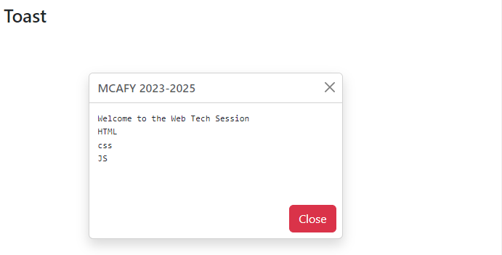

11)Card

<!-- card -->

<h3 class="p-2">Card</h3>

<div class="container p-3">

<div class="card w-50">

<img src="https://images.unsplash.com/photo-1497285597995-6ed7de6bfebd?ixlib=rb-4.0.3&ixid=M3wxMjA3fDB8MHxzZWFyY2h8MTR8fHJhbmRvbSUyMHBob3RvfGVufDB8fDB8fHww&auto=format&fit=crop&w=800&q=60" alt="image" class="card-img-top">

<div class="card-header bg-dark text-white">Card Heading</div>

<div class="card-body">

<div class="card-text">

Lorem ipsum dolor sit amet.

</div>

</div>

<div class="card-footer bg-light">

<a href="" class="text-black">View More</a>

</div>

</div>

</div>

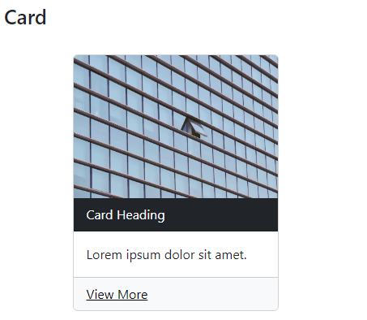

12) Modal

<!-- modal -->

<h3 class="p-2">Modal</h3>

<div class="container p-3">

<button type="button" class="btn btn-info" data-bs-toggle="modal" data-bs-target="#myModal">Open Modal</button>

</div>

<div class="modal" id="myModal">

<div class="modal-dialog">

<div class="modal-content">

<div class="modal-header">MCAFY 2023-25 Exam Alert!!

<button type="button" class="btn-close" data-bs-dismiss="modal"></button></div>

<div class="modal-body">

<p>Lorem ipsum dolor sit amet.</p>

</div>

<div class="modal-footer">

<button type="button" class="btn btn-secondary" data-bs-dismiss="modal">Close</button>

</div>

</div>

</div>

</div>

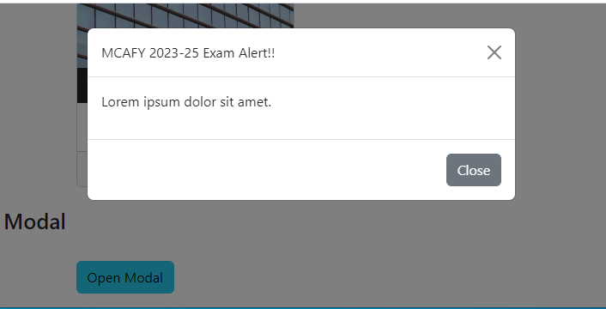

-modal sm

<!-- modal -->

<h3 class="p-2">Modal</h3>

<div class="container p-3">

<button type="button" class="btn btn-info" data-bs-toggle="modal" data-bs-target="#myModal">Open Modal</button>

</div>

<div class="modal" id="myModal">

<div class="modal-dialog modal-sm">

<div class="modal-content">

<div class="modal-header">MCAFY 2023-25 Exam Alert!!

<button type="button" class="btn-close" data-bs-dismiss="modal"></button></div>

<div class="modal-body">

<p>Lorem ipsum dolor sit amet.</p>

</div>

<div class="modal-footer">

<button type="button" class="btn btn-secondary" data-bs-dismiss="modal">Close</button>

</div>

</div>

</div>

</div>

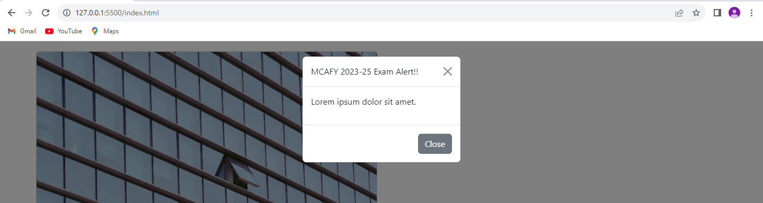

-modal lg

<!-- modal -->

<h3 class="p-2">Modal</h3>

<div class="container p-3">

<button type="button" class="btn btn-info" data-bs-toggle="modal" data-bs-target="#myModal">Open Modal</button>

</div>

<div class="modal" id="myModal">

<div class="modal-dialog modal-lg">

<div class="modal-content">

<div class="modal-header">MCAFY 2023-25 Exam Alert!!

<button type="button" class="btn-close" data-bs-dismiss="modal"></button></div>

<div class="modal-body">

<p>Lorem ipsum dolor sit amet.</p>

</div>

<div class="modal-footer">

<button type="button" class="btn btn-secondary" data-bs-dismiss="modal">Close</button>

</div>

</div>

</div>

</div>

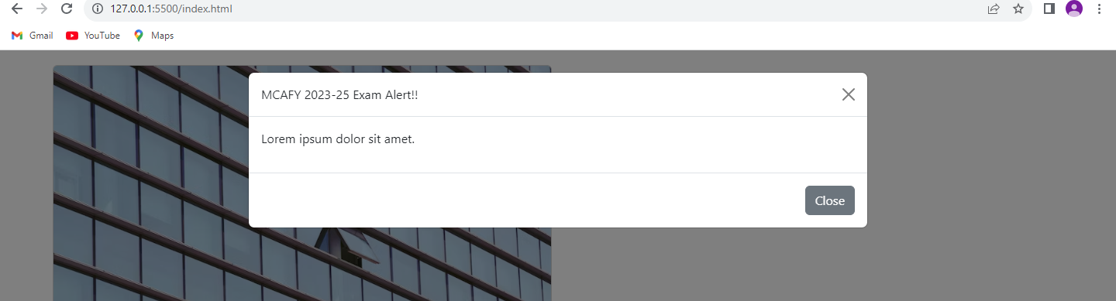

-modal xl

<!-- modal -->

<h3 class="p-2">Modal</h3>

<div class="container p-3">

<button type="button" class="btn btn-info" data-bs-toggle="modal" data-bs-target="#myModal">Open Modal</button>

</div>

<div class="modal" id="myModal">

<div class="modal-dialog modal-xl">

<div class="modal-content">

<div class="modal-header">MCAFY 2023-25 Exam Alert!!

<button type="button" class="btn-close" data-bs-dismiss="modal"></button></div>

<div class="modal-body">

<p>Lorem ipsum dolor sit amet.</p>

</div>

<div class="modal-footer">

<button type="button" class="btn btn-secondary" data-bs-dismiss="modal">Close</button>

</div>

</div>

</div>

</div>

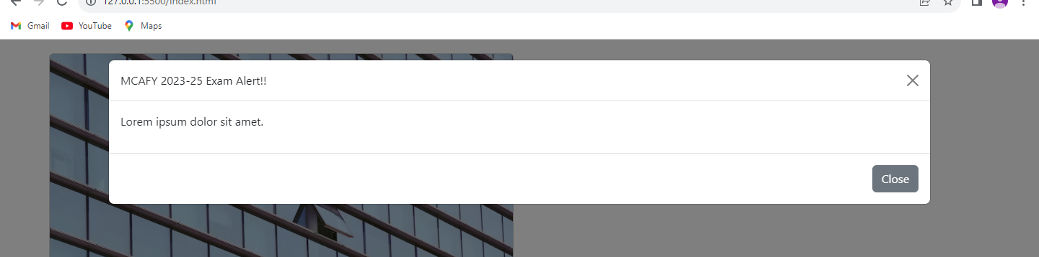

-modal dialog centered

<h3 class="p-2">Modal</h3>

<div class="container p-3">

<button type="button" class="btn btn-info" data-bs-toggle="modal" data-bs-target="#myModal">Open Modal</button>

</div>

<div class="modal" id="myModal">

<div class="modal-dialog modal-dialog-centered">

<div class="modal-content">

<div class="modal-header">MCAFY 2023-25 Exam Alert!!

<button type="button" class="btn-close" data-bs-dismiss="modal"></button></div>

<div class="modal-body">

<p>Lorem ipsum dolor sit amet.</p>

</div>

<div class="modal-footer">

<button type="button" class="btn btn-secondary" data-bs-dismiss="modal">Close</button>

</div>

</div>

</div>

</div>

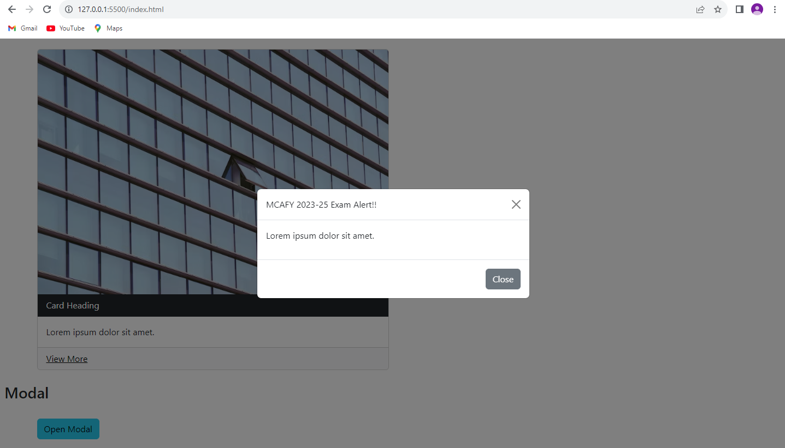

-modal fullscreen

<h3 class="p-2">Modal</h3>

<div class="container p-3">

<button type="button" class="btn btn-info" data-bs-toggle="modal" data-bs-target="#myModal">Open Modal</button>

</div>

<div class="modal" id="myModal">

<div class="modal-dialog modal-fullscreen">

<div class="modal-content">

<div class="modal-header">MCAFY 2023-25 Exam Alert!!

<button type="button" class="btn-close" data-bs-dismiss="modal"></button></div>

<div class="modal-body">

<p>Lorem ipsum dolor sit amet.</p>

</div>

<div class="modal-footer">

<button type="button" class="btn btn-secondary" data-bs-dismiss="modal">Close</button>

</div>

</div>

</div>

</div>

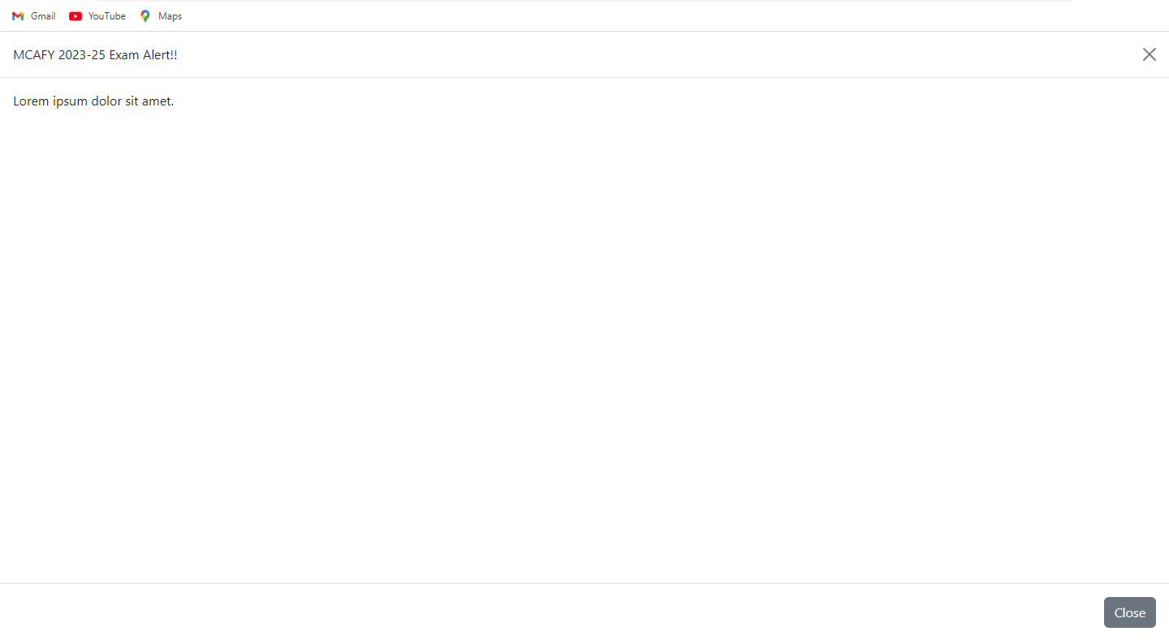

13) OffCanvas

-Start

<!doctype html>

<html lang="en">

<head>

<meta charset="utf-8">

<meta name="viewport" content="width=device-width, initial-scale=1">

<title>Bootstrap demo</title>

<link href="https://cdn.jsdelivr.net/npm/bootstrap@5.3.2/dist/css/bootstrap.min.css" rel="stylesheet"

integrity="sha384-T3c6CoIi6uLrA9TneNEoa7RxnatzjcDSCmG1MXxSR1GAsXEV/Dwwykc2MPK8M2HN" crossorigin="anonymous">

</head>

<body>

<!-- offcanvas -->

<button class="btn btn-primary" type="button" data-bs-toggle="offcanvas" data-bs-target="#myOffcanvas" aria-controls="myOffcanvas">

Open Offcanvas

</button>

<div class="offcanvas offcanvas-start" id="myOffcanvas" aria-labelledby="offcanvasExampleLabel">

<div class="offcanvas-header">

<h5 class="offcanvas-title" id="offcanvasExampleLabel">Offcanvas</h5>

<button type="button" class="btn-close text-reset" data-bs-dismiss="offcanvas" aria-label="Close"></button>

</div>

<div class="offcanvas-body">

<div>

<li>HTML</li>

<li>CSS</li>

<li>JS</li>

</div>

</div>

</div>

<script src="https://cdn.jsdelivr.net/npm/bootstrap@5.3.2/dist/js/bootstrap.bundle.min.js"

integrity="sha384-C6RzsynM9kWDrMNeT87bh95OGNyZPhcTNXj1NW7RuBCsyN/o0jlpcV8Qyq46cDfL"

crossorigin="anonymous"></script>

</body>

</html>

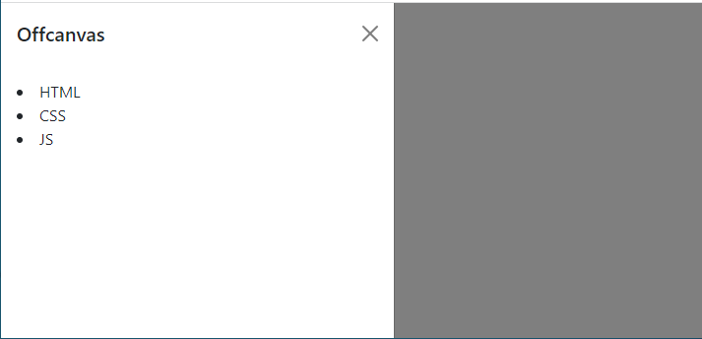

-End

<!doctype html>

<html lang="en">

<head>

<meta charset="utf-8">

<meta name="viewport" content="width=device-width, initial-scale=1">

<title>Bootstrap demo</title>

<link href="https://cdn.jsdelivr.net/npm/bootstrap@5.3.2/dist/css/bootstrap.min.css" rel="stylesheet"

integrity="sha384-T3c6CoIi6uLrA9TneNEoa7RxnatzjcDSCmG1MXxSR1GAsXEV/Dwwykc2MPK8M2HN" crossorigin="anonymous">

</head>

<body>

<!-- offcanvas -->

<button class="btn btn-primary" type="button" data-bs-toggle="offcanvas" data-bs-target="#myOffcanvas" aria-controls="myOffcanvas">

Open Offcanvas

</button>

<div class="offcanvas offcanvas-end" id="myOffcanvas" aria-labelledby="offcanvasExampleLabel">

<div class="offcanvas-header">

<h5 class="offcanvas-title" id="offcanvasExampleLabel">Offcanvas</h5>

<button type="button" class="btn-close text-reset" data-bs-dismiss="offcanvas" aria-label="Close"></button>

</div>

<div class="offcanvas-body">

<div>

<li>HTML</li>

<li>CSS</li>

<li>JS</li>

</div>

</div>

</div>

<script src="https://cdn.jsdelivr.net/npm/bootstrap@5.3.2/dist/js/bootstrap.bundle.min.js"

integrity="sha384-C6RzsynM9kWDrMNeT87bh95OGNyZPhcTNXj1NW7RuBCsyN/o0jlpcV8Qyq46cDfL"

crossorigin="anonymous"></script>

</body>

</html>

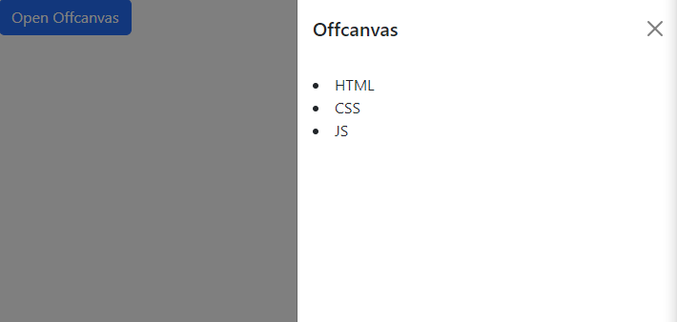

-Top

<!doctype html>

<html lang="en">

<head>

<meta charset="utf-8">

<meta name="viewport" content="width=device-width, initial-scale=1">

<title>Bootstrap demo</title>

<link href="https://cdn.jsdelivr.net/npm/bootstrap@5.3.2/dist/css/bootstrap.min.css" rel="stylesheet"

integrity="sha384-T3c6CoIi6uLrA9TneNEoa7RxnatzjcDSCmG1MXxSR1GAsXEV/Dwwykc2MPK8M2HN" crossorigin="anonymous">

</head>

<body>

<!-- offcanvas -->

<button class="btn btn-primary" type="button" data-bs-toggle="offcanvas" data-bs-target="#myOffcanvas" aria-controls="myOffcanvas">

Open Offcanvas

</button>

<div class="offcanvas offcanvas-top" id="myOffcanvas" aria-labelledby="offcanvasExampleLabel">

<div class="offcanvas-header">

<h5 class="offcanvas-title" id="offcanvasExampleLabel">Offcanvas</h5>

<button type="button" class="btn-close text-reset" data-bs-dismiss="offcanvas" aria-label="Close"></button>

</div>

<div class="offcanvas-body">

<div>

<li>HTML</li>

<li>CSS</li>

<li>JS</li>

</div>

</div>

</div>

<script src="https://cdn.jsdelivr.net/npm/bootstrap@5.3.2/dist/js/bootstrap.bundle.min.js"

integrity="sha384-C6RzsynM9kWDrMNeT87bh95OGNyZPhcTNXj1NW7RuBCsyN/o0jlpcV8Qyq46cDfL"

crossorigin="anonymous"></script>

</body>

</html>

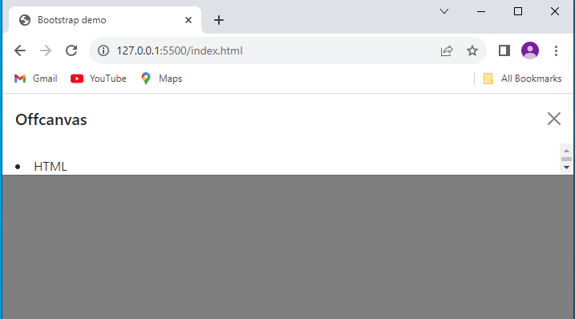

-bottom

<!doctype html>

<html lang="en">

<head>

<meta charset="utf-8">

<meta name="viewport" content="width=device-width, initial-scale=1">

<title>Bootstrap demo</title>

<link href="https://cdn.jsdelivr.net/npm/bootstrap@5.3.2/dist/css/bootstrap.min.css" rel="stylesheet"

integrity="sha384-T3c6CoIi6uLrA9TneNEoa7RxnatzjcDSCmG1MXxSR1GAsXEV/Dwwykc2MPK8M2HN" crossorigin="anonymous">

</head>

<body>

<!-- offcanvas -->

<button class="btn btn-primary" type="button" data-bs-toggle="offcanvas" data-bs-target="#myOffcanvas" aria-controls="myOffcanvas">

Open Offcanvas

</button>

<div class="offcanvas offcanvas-bottom" id="myOffcanvas" aria-labelledby="offcanvasExampleLabel">

<div class="offcanvas-header">

<h5 class="offcanvas-title" id="offcanvasExampleLabel">Offcanvas</h5>

<button type="button" class="btn-close text-reset" data-bs-dismiss="offcanvas" aria-label="Close"></button>

</div>

<div class="offcanvas-body">

<div>

<li>HTML</li>

<li>CSS</li>

<li>JS</li>

</div>

</div>

</div>

<script src="https://cdn.jsdelivr.net/npm/bootstrap@5.3.2/dist/js/bootstrap.bundle.min.js"

integrity="sha384-C6RzsynM9kWDrMNeT87bh95OGNyZPhcTNXj1NW7RuBCsyN/o0jlpcV8Qyq46cDfL"

crossorigin="anonymous"></script>

</body>

</html>

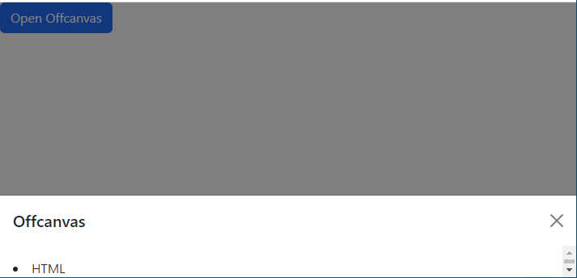

**ANGULAR JS**

Angular JS Experssion

**<!DOCTYPE html>**

**<html lang="en">**

**<head>**

**<meta charset="UTF-8">**

**<meta name="viewport" content="width=device-width, initial-scale=1.0">**

**<title>Angular</title>**

**<script src="./ajax.googleapis.com_ajax_libs_angularjs_1.8.2_angular.min.js"></script>**

**</head>**

**<body>**

**<div ng-app="">**

**<!-- angular js expression {{}} -->**

**<h3>hello, {{5+5}}</h3>**

**</div>**

**</body>**

**</html>**

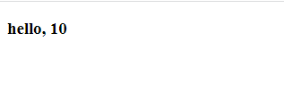

Arrays

<!DOCTYPE html>

<html lang="en">

<head>

<meta charset="UTF-8">

<meta name="viewport" content="width=device-width, initial-scale=1.0">

<title>Angular</title>

<script src="./ajax.googleapis.com_ajax_libs_angularjs_1.8.2_angular.min.js"></script>

</head>

<body ng-app="">

<!-- arrays -->

<div ng-init="subject=['webtech', 'AI' , 'DMBS']">

<h3>{{subject[0]}}</h3>

<h3>{{subject[1]}}</h3>

<h3>{{subject[2]}}</h3>

</div>

</body>

</html>

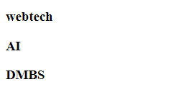

**Repeat**

**<!DOCTYPE html>**

**<html lang="en">**

**<head>**

**<meta charset="UTF-8">**

**<meta name="viewport" content="width=device-width, initial-scale=1.0">**

**<title>Angular</title>**

**<script src="./ajax.googleapis.com_ajax_libs_angularjs_1.8.2_angular.min.js"></script>**

**</head>**

**<body ng-app="">**

**<div ng-init="friends=['abc','xyz' , 'pqr']">**

**<h3>Friends List</h3>**

**<ul ng-repeat="x in friends">**

**<li>{{x}}</li>**

**</ul>**

**</div>**

**</body>**

**</html>**

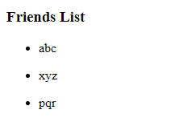

**Objects**

**<!DOCTYPE html>**

**<html lang="en">**

**<head>**

**<meta charset="UTF-8">**

**<meta name="viewport" content="width=device-width, initial-scale=1.0">**

**<title>Angular</title>**

**<link href="https://cdn.jsdelivr.net/npm/bootstrap@5.3.2/dist/css/bootstrap.min.css" rel="stylesheet" integrity="sha384-T3c6CoIi6uLrA9TneNEoa7RxnatzjcDSCmG1MXxSR1GAsXEV/Dwwykc2MPK8M2HN" crossorigin="anonymous">**

**<script src="./ajax.googleapis.com_ajax_libs_angularjs_1.8.2_angular.min.js"></script>**

**</head>**

**<body ng-app="">**

**<div ng-init="friends=['abc','xyz' , 'pqr']">**

**<h3>Friends List</h3>**

**<div ng-repeat="a in friends">**

**<p>{{a}}</p>**

**</div>**

**</div>**

**<div ng-init="emp={title:'Title 1', text: 'some text in the card' , link1 : 'link-1' , link2: 'link-2'}">**

**<div class="container">**

**<div class="row">**

**<div class="col">**

**<div class="card" style="width: 18rem;">**

**<div class="card-body">**

**<h5 class="card-title">{{emp.title}}</h5>**

**<p>{{emp.text}}**

**</p>**

**<a href="#" class="card-link">{{emp.link1}}</a>**

**<a href="#" class="card-link">{{emp.link2}}</a>**

**</div>**

**</div>**

**</div>**

**</div>**

**</div>**

**</div>**

**</body>**

**</html>**

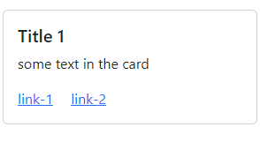

**Array of objects**

**<!DOCTYPE html>**

**<html lang="en">**

**<head>**

**<meta charset="UTF-8">**

**<meta name="viewport" content="width=device-width, initial-scale=1.0">**

**<title>Angular</title>**

**<link href="https://cdn.jsdelivr.net/npm/bootstrap@5.3.2/dist/css/bootstrap.min.css" rel="stylesheet"**

**integrity="sha384-T3c6CoIi6uLrA9TneNEoa7RxnatzjcDSCmG1MXxSR1GAsXEV/Dwwykc2MPK8M2HN" crossorigin="anonymous">**

**<script src="./ajax.googleapis.com_ajax_libs_angularjs_1.8.2_angular.min.js"></script>**

**</head>**

**<body ng-app="">**

**<div ng-init="tabledata = [**

**{name: 'Pranjal', email: 'pranjal@gmail.com' , number : '2395454'},**

**{name: 'Prachi', email: 'prachi@gmail.com' , number : '454652'},**

**{name: 'Pratik', email: 'pratik@gmail.com' , number : '467685'},**

**{name: 'Karan', email: 'karan@gmail.com' , number : '2395454'},**

**{name: 'Falguni', email: 'falguni@gmail.com' , number : '8765646'}]">**

**<table class="table">**

**<thead>**

**<tr class="table-info">**

**<th>Name</th>**

**<th>Email</th>**

**<th>Number</th>**

**</tr>**

**</thead>**

**<tbody>**

**<tr ng-repeat="x in tabledata">**

**<td>{{x.name}}</td>**

**<td>{{x.email}}</td>**

**<td>{{x.number}}</td>**

**</tr>**

**</tbody>**

**</table>**

**</div>**

**</div>**

**</body>**

**</html>**

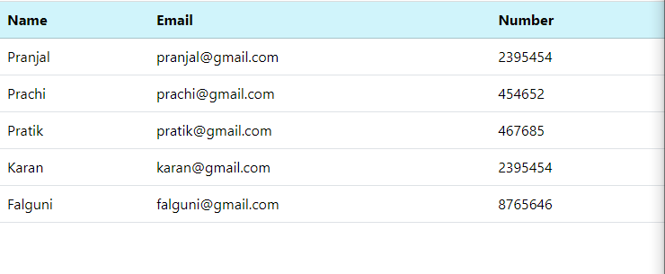

**Display data in modal**

**<!DOCTYPE html>**

**<html lang="en">**

**<head>**

**<meta charset="UTF-8">**

**<meta name="viewport" content="width=device-width, initial-scale=1.0">**

**<title>Angular</title>**

**<link href="https://cdn.jsdelivr.net/npm/bootstrap@5.3.2/dist/css/bootstrap.min.css" rel="stylesheet"**

**integrity="sha384-T3c6CoIi6uLrA9TneNEoa7RxnatzjcDSCmG1MXxSR1GAsXEV/Dwwykc2MPK8M2HN" crossorigin="anonymous">**

**<script src="./ajax.googleapis.com_ajax_libs_angularjs_1.8.2_angular.min.js"></script>**

**</head>**

**<body ng-app="">**

**<div class="container-xxl p-2">**

**<button type="button" class="btn btn-info" data-bs-toggle="modal" data-bs-target="#myModal">Click to view**

**data</button>**

**<div class="modal" id="myModal">**

**<div class="modal-dialog">**

**<div class="modal-content">**

**<div class="modal-header">**

**<h5 class="modal-title">Student Data</h5>**

**<button type="button" class="btn-close" data-bs-dismiss="modal"></button>**

**</div>**

**<div class="modal-body">**

**<div ng-init="tabledata = [**

**{name: 'Pranjal', email: 'pranjal@gmail.com' , number : '2395454'},**

**{name: 'Prachi', email: 'prachi@gmail.com' , number : '454652'},**

**{name: 'Pratik', email: 'pratik@gmail.com' , number : '467685'},**

**{name: 'Karan', email: 'karan@gmail.com' , number : '2395454'},**

**{name: 'Falguni', email: 'falguni@gmail.com' , number : '8765646'}]">**

**<table class="table">**

**<thead>**

**<tr class="table-info">**

**<th>Name</th>**

**<th>Email</th>**

**<th>Number</th>**

**</tr>**

**</thead>**

**<tbody>**

**<tr ng-repeat="x in tabledata">**

**<td>{{x.name}}</td>**

**<td>{{x.email}}</td>**

**<td>{{x.number}}</td>**

**</tr>**

**</tbody>**

**</table>**

**</div>**

**</div>**

**<div class="modal-footer">**

**<button type="button" class="btn btn-secondary" data-bs-dismiss="modal">Close</button>**

**</div>**

**</div>**

**</div>**

**</div>**

**</div>**

**<script src="https://cdn.jsdelivr.net/npm/bootstrap@5.3.2/dist/js/bootstrap.bundle.min.js"**

**integrity="sha384-C6RzsynM9kWDrMNeT87bh95OGNyZPhcTNXj1NW7RuBCsyN/o0jlpcV8Qyq46cDfL"**

**crossorigin="anonymous"></script>**

**</body>**

**</html>**

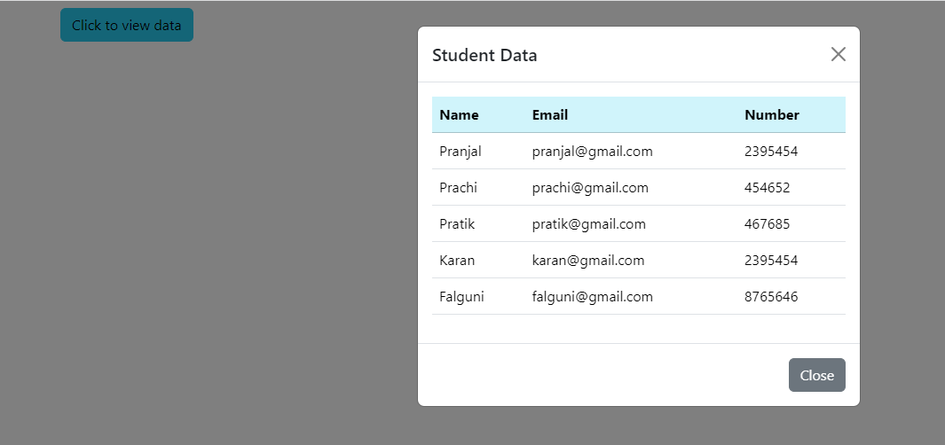

**Bind**

**<div ng-init="quantity=2;price=20">**

**<h1>Total Price: <span ng-bind="quantity*price"></span></h1>**

**</div>**

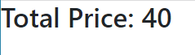

**Bind with input**

**<div ng-init="quantity=2;price=20">**

**Quantity <input type="number" class="form-control" ng-model="quantity">**

**Price <input type="number" class="form-control" ng-model="price">**

**<h1>Total Price: <span ng-bind="quantity*price"></span></h1>**

**</div>**

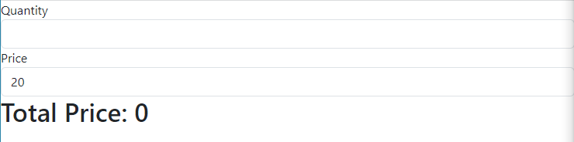

**Form Validation**

**<!DOCTYPE html>**

**<html lang="en">**

**<head>**

**<meta charset="UTF-8">**

**<meta name="viewport" content="width=device-width, initial-scale=1.0">**

**<title>Angular</title>**

**<link href="https://cdn.jsdelivr.net/npm/bootstrap@5.3.2/dist/css/bootstrap.min.css" rel="stylesheet"**

**integrity="sha384-T3c6CoIi6uLrA9TneNEoa7RxnatzjcDSCmG1MXxSR1GAsXEV/Dwwykc2MPK8M2HN" crossorigin="anonymous">**

**<script src="./ajax.googleapis.com_ajax_libs_angularjs_1.8.2_angular.min.js"></script>**

**<style>**

**input.ng-invalid{**

**background-color: red;**

**}**

**input.ng-empty{**

**background-color: cadetblue;**

**}**

**input.ng-touched{**

**background-color: aqua;**

**}**

**</style>**

**</head>**

**<body ng-app="">**

**<!-- Form Validation -->**

**<form name="myForm">**

**<input type="email" name="email" ng-model="email">**

**<span ng-show="myForm.email.$error.email">invalid email</span>**

**<br><br>**

**<input type="text" ng-model="mytext">**

**</form>**

**<script src="https://cdn.jsdelivr.net/npm/bootstrap@5.3.2/dist/js/bootstrap.bundle.min.js"**

**integrity="sha384-C6RzsynM9kWDrMNeT87bh95OGNyZPhcTNXj1NW7RuBCsyN/o0jlpcV8Qyq46cDfL"**

**crossorigin="anonymous"></script>**

**</body>**

**</html>**

